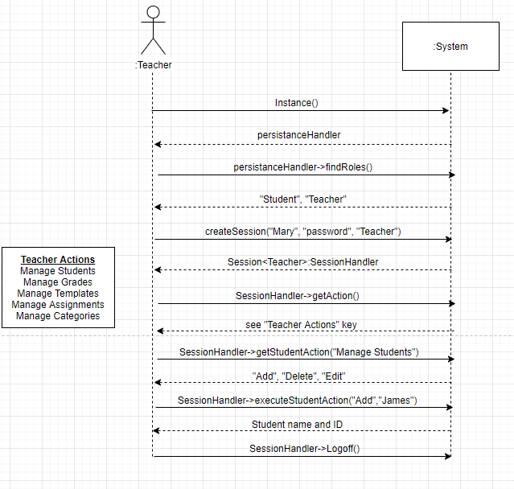

UC 1 Manage Student:

In this use case the teacher actor will add a student. First the teacher will authenticate themselves to the system using their name “Mary”, password “password”, and enter their role as “Teacher”. The system shall return a list of actions shown on the left under Teacher Actions. The teacher will then execute the action “Manage Students” and the system shall return another list of actions to execute: Add, Edit, and Delete. From there the teacher will execute the action “Add” with the name of the student they wish to add, in this example the name is “James”. The system shall return the name of the newly added student (James) as well as their ID number (101). The teacher will then logoff.